### PROJECT REPORT

### On

### “3D CAR ANIMATION”

*Submitted in partial fulfillment of*

*Computer Graphics and Laboratory with mini project(17CSL68)*

# Sixth Semester of the Degree of Bachelor of Engineering

# in

**Department of Computer Science and Engineering**



#### Visvesvaraya Technological University, Belagavi

#### during the year 2019-20

Carried out by

**Name: VASUDEVARAJU B K USN: 1SB17CS093**

**Name: PRASANNA R USN: 1SB17CS063**

**Under the guidance of**

**Mrs. REMYA SIVAN**

**Assistant Professor**

**Dept. of Computer Science and Engg.**

|  |  |  |
| --- | --- | --- |
|  | **Sri Sairam College of Engineering**  **Sai Leo Nagar, Guddanahalli Post,**  **Anekal, Bengaluru – 562106** | C:\Users\Suraj Sivakumar\Downloads\Untitled1.png |



#### Department of Computer Science and Engineering

#### CERTIFICATE

Certified that the project entitled **3D CAR ANIMATION** is a bonafide work carried out by **VASUDEVARAJU B K, 1SB17CS093** and **PRASANNA R, 1SB17CS063** in partial fulfillment of sixth semester of the degree of bachelor of engineering in **Computer Science and Engineering** of the Visvesvaraya Technological University, Belgaum during the year **2019-2020**. It is certified that all corrections/suggestions indicated for Internal Assessment have been incorporated in the report deposited in the department library. The project has been approved as it satisfies the academic requirements in respect of project work prescribed for the Bachelor of Engineering Degree.

Signature of the Guide Signature of the HOD

Mrs. Remya Sivan Dr.G.Manjula

Asst.Prof, CSE Dept HOD, CSE Dept

SSCE SSCE

External Viva  
Name of the Examiners: 1. ____________________________  
 2. __________________________

**ABSTRACT**

3D computer graphics or three-dimensional computer graphics (in contrast with 2D computer graphics) are graphics that use a three-dimensional representation of geometric data that is stored in the computer for the purposes of performing calculations and rendering 2D images. Such images may be stored for viewing later or displayed in real time. 3D computer graphics rely on many of the same algorithms as 2D computer vector graphics in the wire frame model and 2D computer raster graphics in the final rendered display. In computer graphics software, 2D applications may use 3D techniques to achieve effects such as lighting, and 3D may use 2D rendering techniques.

3D computer graphics are often referred to as 3D models. Apart from the rendered graphic, the model is contained within the graphical data file. However, there are differences: a 3D model is mathematical representation of any three-dimensional object. A model is not technically a graphic until it is displayed. A model can be displayed visually as a two-dimensional image through a process called 3D rendering or used in non-graphical computer simulations and calculations. With 3D printing, 3D models are similarly rendered into a 3D physical representation of the model, with limitations to how accurate the rendering can match the virtual model

**ACKNOWLEDGEMENT**

It has been an honor and privilege to do my project on **3D CAR ANIMATION.**I take this opportunity to convey my sincere thanks and regards to Our Chairman and Chief Executive Officer **Sri. Sai Prakash Leo Muthu**, and **Dr. Arun Kumar R**, Management Representative for offered me a chance to study in this institute and everyone who has helped me in successful completion of this seminar.

I take immense pleasure in expressing my sincere gratitude to **Dr. B SHADAKSHARAPPA, Principal, Sri Sairam College of Engineering, Bengaluru** for giving me a constant encouragement and support to achieve my goal.

My sincere thanks to **Dr.G.Manjula, Professor & Head, Dept. of Computer Science and Engineering** for permitting us to undertake the project work and for her invaluable guidance.

I would like to thank my guide **Mrs. REMYA SIVAN, Asst. Prof**, **Dept. of Computer Science and Engineering,** without her constant motivation and guidance at every stage of this project, this work could not have been materialized.

I perceive as this opportunity as a big milestone in my career development. I will strive to use gained skills and knowledge in the best possible way, and will continue to work on their improvement, in order to attain desired career objectives. Hope to continue cooperation with all of you in the future.

# CONTENTS

|  |  |  |
| --- | --- | --- |
| S. No. | TOPICS | PAGE NO. |
| 1 | Introduction | 7 |
| 1.1 | COMPUTER GRAPHICS | 7 |
| 1.2 | OpenGL CONCEPT | 7 |
| 1.21 | INTERFACE | 7 |
| 1.22 | OVERVIEW | 8 |
| 1.23 | OPENGL ARCHITECTURE | 8 |
| 2 | REQUIREMENT SPECIFICATION | 11 |
| 2.1 | SOFTWARE REQUIREMENTS SPECIFICATION | 11 |
| 2.2 | EXTERNAL INTERFACE REQUIREMENTS | 11 |
| 3 | SYSTEM DESIGN | 12 |
| 4 | IMPLEMENTATION SOURCE CODE | 14 |
| 5 | RESULTS | 31 |
| 6 | TESTING | 34 |
| 6.1 | LIFE CYCLE OF TESTING | 34 |
| 6.2 | TYPES OF TESTING | 34 |
| 6.3 | REGRESSION TESTING | 35 |
| 7 | CONCLUSION | 37 |
| 8 | BIBILIOGRAPHY | 38 |

# List of Figures

|  |  |  |
| --- | --- | --- |
| Figure No. | TOPICS | PAGE NO. |
| 1.1 | Overview of Computer Graphics | 7 |
| 1.2.3.1 | OpenGL Pipeline Architecture | 8 |
| 1.2.3.2 | OpenGL Engine and Drivers | 9 |
| 1.2.3.3 | Application Development (API’s) | 10 |
| 6.1 | Testing life cycle | 34 |

# List of Snapshots

|  |  |  |
| --- | --- | --- |
| Table No. | TOPICS | PAGE NO. |
| 5.1 | Starting menu of the project | 31 |
| 5.2 | Inside the project | 31 |
| 5.3 | Different car options | 32 |
| 5.4 | Car Driving Mode | 32 |
| 5.5 | Wheel Effect | 33 |
| 5.6 | Night mode | 33 |

**1.INTRODUCTION**

1. **COMPUTER GRAPHICS**

In this era of computing, computer graphics has become one of the most powerful and interesting fact of computing. It all started with display of data on hardcopy and CRT screen. Now computer graphics is about creation, retrieval, manipulation of models and images.

Graphics today is used in many different areas. Graphics provides one of the most natural means of communicating within a computer, since our highly developed 2D and 3D pattern-recognition abilities allow us to perceive and process pictorial data rapidly and effectively. Interactive computer graphics is the most important means of producing pictures since the invention of photography and television. It has the added advantage that, with the computer, we can make pictures not only of concrete real world objects but also of abstract, synthetic objects, such as mathematical surfaces and of data that have no inherent geometry, such as survey results.

OpenGL is an application program interface (API) offering various functions to implement primitives, models and images. This offers functions to create and manipulate render lighting, coloring, viewing the models. OpenGL offers different coordinate system and frames. OpenGL offers translation, rotation and scaling of objects.

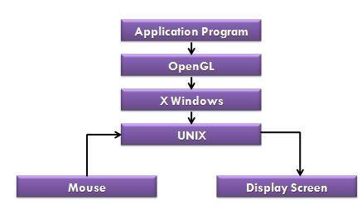

**FIG:1.1** **OVERVIEW OF COMPUTER GRAPHICS**

**1.2 OpenGL CONCEPT**

**1.2.1 INTERFACE**

OpenGL is an application program interface (API) offering various functions to implement primitives, models and images. This offers functions to create and manipulate render lighting, coloring, viewing the models. OpenGL offers different coordinate system and frames. OpenGL offers translation, rotation and scaling of objects. Functions in the main GL library have names that begins with *gl* and are stored in a library usually referred to as GL. The second is the **OpenGL Utility Library(GLU)**. The library uses only GL functions but contains code for creating common objects and simplifying viewing.

All functions in GLU can be created from the core GL library but application programmers prefer not to write the code repeatedly. The GLU library is available in all OpenGL implementations; functions in the GLU library begin with the letter *glu*. Rather than using a different library for each system we use a readily available library called OpenGL Utility Toolkit(GLUT),which provides the minimum functionality that should be expected in any modern windowing system.

* 1. **OVERVIEW**
* OpenGL(Open Graphics Library) is the interface between a graphics program and graphics hardware. *It is streamlined*. In other words, it provides low-level functionality. For example, all objects are built from points, lines and convex polygons. Higher level objects like cubes are implemented as six four-sided polygons.
* OpenGL supports features like 3-dimensions, lighting, anti-aliasing, shadows, textures, depth effects, etc.
* It is system-independent. It does not assume anything about hardware or operating system and is only concerned with efficiently rendering mathematically described scenes. As a result, it does not provide any windowing capabilities.
* It is a state machine. At any moment during the execution of a program there is a current model transformation.
* It is a rendering pipeline. The rendering pipeline consists of the following steps:
  + - Defines objects mathematically.

* Arranges objects in space relative to a viewpoint.

* Calculates the color of the objects.

* + 1. **OPENGL ARCHITECTURE:**
  1. **Pipeline Architectures**

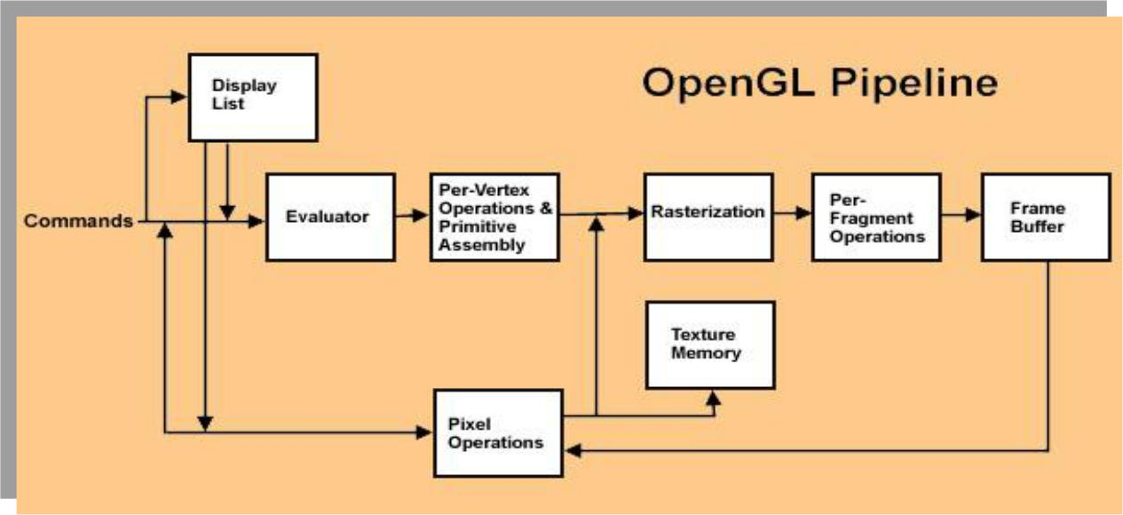

**FIG:1.2.3.1 OPENGL PIPELINE ARCHITECTURE**

**2) OpenGL Engine and Drivers**

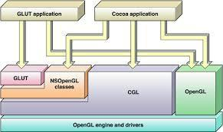

**FIG:1.2.3.2 OPENGL ENGINE AND DRIVERS**

**3) Application Development-API’s**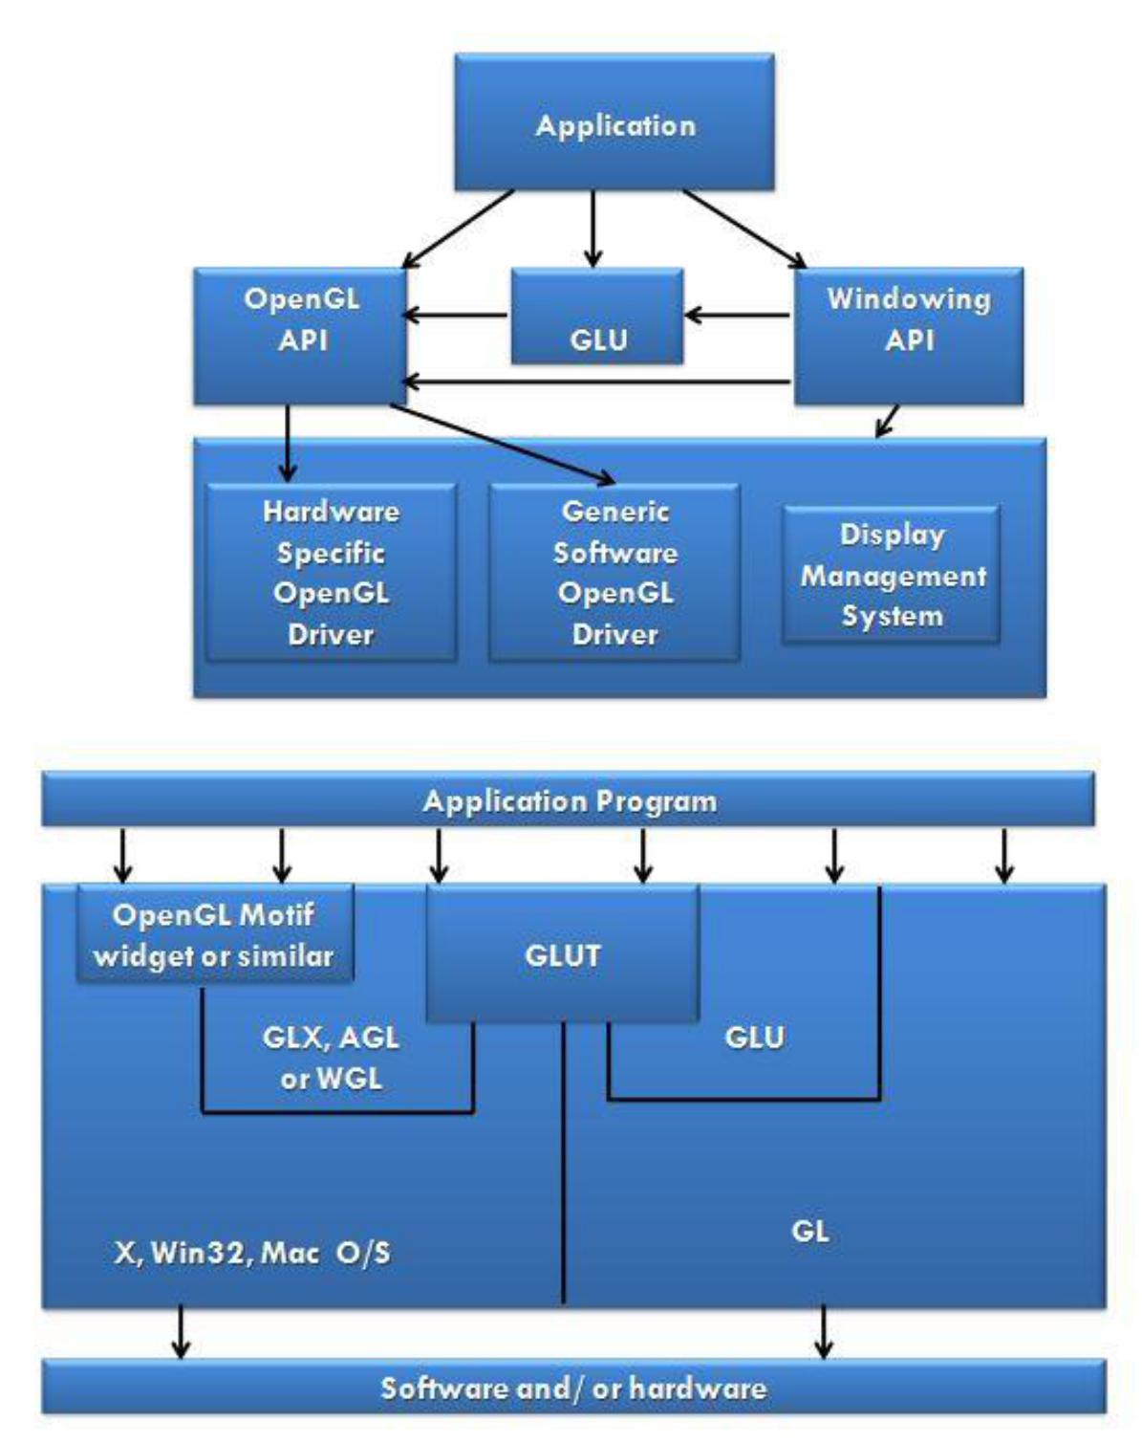

**FIG:1.2.3.3 APPLICATIONS DEVELOPMENT(API’S)**

The above diagram illustrates the relationship of the various libraries and window system

components.

Generally, applications which require more user interface support will use a library designed to support those types of features (i.e. buttons, menu and scroll bars, etc.) such as Motif or the Win32 API.

Prototype applications, or ones which do not require all the bells and whistles of a full GUI, may choose to use GLUT instead because of its simplified programming model and window system independence.

**Display Lists:**

All data, whether it describes geometry or pixels, can be saved in a *display list* for current or later use. (1 alternative to retaining data in a displaylist is processing the data immediately - also known as *immediate mode*.) When a display list is executed, the retained data is sent from the display list just as if it were sent by the application in immediate mode.

**Evaluators:**

All geometric primitives are eventually described by vertices. Parametric curves and surfaces may be initially described by control points and polynomial functions called basis functions. Evaluators provide a method to derive the vertices used to represent the surface from the control points. The method is a polynomial mapping, which can produce surface normal, texture coordinates, colors, and spatial coordinate values from the control points.

**Per-Vertex Operations**

For vertex data, next is the "per-vertex operations" stage, which converts. The vertices into primitives. Some vertex data (for example, spatial coordinates) are transformed by 4 x 4 floating-point matrices. Spatial coordinates are projected from a position in the 3D world to a position on your screen.

If advanced features are enabled, this stage is even busier. If texturing is used, texture coordinates may be generated and transformed here. If lighting is enabled, the lighting calculations are performed using the transformed vertex, surface normal, light source position, material properties, and other lighting information to produce a color value.

**Primitive Assembly**

Clipping, a major part of primitive assembly, is the elimination of portions of geometry which fall outside a half-space, defined by a plane. Point clipping simply passes or rejects vertices; line or polygon clipping can add additional vertices depending upon how the line or polygon is clipped.

In some cases, this is followed by perspective division, which makes distant geometric objects appear smaller than closer objects. Then view port

and depth (z coordinate) operations are applied. If culling is enabled and the primitive is a polygon, it then may be rejected by a culling test. Depending upon the polygon mode, a polygon may be drawn as points or lines. The results or this stage are complete geometric primitives, which are the transformed and clipped vertices with related color, depth, and sometimes texture-coordinate values and guidelines for the rasterization step.

**Pixel Operations**

While geometric data takes one path through the OpenGL rendering pipeline, pixel data takes a different route. Pixels from an array in system memory are first unpacked from one of a variety of formats into the proper number of components. Next the data is scaled, biased, and processed by a pixel map. The results are clamped and then either written into texture memory or sent to the rasterization step. If pixel data is read from the frame buffer, pixel-transfer operations (scale, bias, mapping, and clamping) are performed. Then these results are packed into an appropriate format and returned to an array in system memory. There are special pixel copy operations to copy data in the frame buffer to other parts of the frame buffer or to the texture memory. A single pass is made through the pixel transfer operations before the data is written to the texture memory or back to the frame buffer.

**Texture Assembly**

An OpenGL application may wish to apply texture images onto geometric objects to make them look more realistic. If several texture images are used, it's wise to put them into texture objects so that you can easily switch among them. Some OpenGL implementations may have special resources to accelerate texture performance. There may be specialized, high-performance texture memory. If this memory is available, the texture objects may be prioritized to control the use of this limited and valuable resource.

**Rasterization**

Rasterization is the conversion of both geometric and pixel data into fragments. Each fragment square corresponds to a pixel in the frame buffer. Line and polygon stipples, line width, point size, shading model, and coverage calculations to support ant aliasing are taken into consideration as vertices are connected into lines or the interior pixels are calculated for a filled polygon. Color and depth values are assigned for each fragment square.

**2.REQUIREMENT SPECIFICATION**

1. **SOFTWARE REQUIREMENTS SPECIFICATION**

This section attempts to bring out the requirements and specifications as given out by the Visvesvaraya Technological University for the completion of the package. Minimum requirements expected are cursor movement, editing picture objects like point, line, circle, ellipse and polygons. Transformations on objects/selected area should be possible. User should be able to open the package do the required operations and exit from the environment.

**2.2 EXTERNAL INTERFACE REQUIREMENTS**

**User Interface:**

The interface for the 2D package requires for the user to have a mouse connected, and the corresponding drivers software and header files installed. For the convenience of the user, there are menus and sub -menus displayed on the screen.

**Menus:**

The Menus consists of various operations related to drawing on the area specified. It also has the 'clear' option for clearing the screen and also changes the background color.

**Hardware Interface:**

The standard output device, as mentioned earlier has been assumed to be a color monitor. It is quite essential for any graphics package to have this, as provision of color options to the user is a must. The mouse, the main input device, has to be functional. A keyboard is also required. .

Apart from these hardware requirements, there should be sufficient hard disk space and primary memory available for proper working of the package.

**Software Interface:**

The editor has been implemented on the DOS platform and mainly requires an appropriate version of the compiler to be installed and functional. Though it has been implemented on DOS, it is pretty much platform independent with the

**Hardware Requirements:**

|  |  |  |
| --- | --- | --- |
| **System** | **:** | **Intel** |
| **Frequency** | **:** | **3.0 GHz** |
| **RAM** | **:** | **4 GB** |
| **Disk Capacity** | **:** | **500 GB** |

**Software Requirements:**

**Operating System :** **WINDOWS XP/7/8**

**Compiler, IDE : MS Visual Studio 2013 or** **later**

**3.SYSTEM DESIGN**

In this project we are presenting 3D Car Animation, which is one the best OpenGL Car Program. This 3D OpenGL Program have so many advance features in it. We can see below the all features that included in this 3D Animated Program.

**Features of the 3D Car Animation OpenGL Program:**

1. Start Screen: As you execute the program, first thing come is the start screen where you will see the details of the project. The start screen has name of college and the name of projects. It also has the user interaction instructions about the use of mouse and keyboard functionality. There is option of going to main screen, by pressing 'space' key.

2. Main Screen: After you get in to main screen from the start screen you will see the 3D Car drawn in blue color. If you press right mouse button you will get the menu options to select for particular functionality to execute. Details is mentioned in below user interaction section.

3. Comments: Most of the codes in this 3D OpenGL Program, is commented hence easy to understand the whole program.

**User Interaction:**

The user interaction is one of the most important part of any program. This 3D OpenGL Program also have user interaction both using keyboard as well as mouse. Below is the description of the uses and functionality of keys and menus in this 3D OpenGL Program.

1. Mouse Interaction: Press right mouse button to get the mouse. Following is the menus-

• Car model mode - This is default mode of car display which will display the only car.

• Car driving mode - This will display the driving mode, which includes the long road and green filed.

• Wheel effect - This is one of the finest effects, it will animate the car while it moved as it is moving in the car.

• Toggle light - This will apply the light effect on/off when selected.

• Car colors - This menu has submenu which allow to select the color of car. The submenu has the following options - blue, red, green, black, yellow and grey.

• Day mode - By default we have Day mode on, in this project so while in Night mode you can select this to toggle to Daylight mode.

• Night mode - This menu will let you switching to the Night mode, by showing darkness around.

2. Keyboard Interaction: Below is complete description against each key and what they do when pressed.

• x- Rotate the car in 'x' direction

• y- Rotate the car in 'y' direction

• z- Rotate the car in 'z' direction

• a- Increase the size of car in 'x' direction

• s- Increase the size of car in 'y' direction

• q- Increase the size of car in 'z' direction

• u- Camera top view

• f- Camera side view

• left arrow key - Move car in forward direction

• right arrow key- Move car in backward direction

• spacebar - Enter the main screen from start screen / esc - Exit from the program.

**4. IMPLEMENTATION SOURCE CODE**

#include <stdio.h>

#include <stdlib.h>

#include <GL/glut.h>

#include <math.h>

#include <string.h>

#define ESCAPE 27

GLint window;

GLint window2;

GLint Xsize=1000;

GLint Ysize=800;

float i,theta;

GLint nml=0,day=1;

char name3[]="PROJECT: 3D CAR ANIMATION";

GLfloat xt=0.0,yt=0.0,zt=0.0,xw=0.0;

GLfloat xs=1.0,ys=1.0,zs=1.0;

GLfloat xangle=0.0,yangle=0.0,zangle=0.0,angle=0.0;

GLfloat r=0,g=0,b=1;

GLint light=1;

int count=1,flg=1;

int view=0;

int flag1=0,aflag=1; //to switch car driving mode

int flag2=0,wheelflag=0; //to switch fog effect

GLUquadricObj *t;

static void SpecialKeyFunc( int Key, int x, int y );

GLvoid Transform(GLfloat Width, GLfloat Height)

{

glViewport(0, 0, Width, Height);

glMatrixMode(GL_PROJECTION);

glLoadIdentity();

gluPerspective(45.0,Width/Height,0.1,100.0);

glMatrixMode(GL_MODELVIEW);

}

GLvoid InitGL(GLfloat Width, GLfloat Height)

{

glClearColor(1.0, 1.0, 1.0, 1.0);

glLineWidth(2.0); /* Add line width, ditto */

Transform( Width, Height ); /* Perform the transformation */

t=gluNewQuadric();

gluQuadricDrawStyle(t, GLU_FILL);

glEnable(GL_LIGHTING);

glEnable(GL_LIGHT0);

GLfloat ambientLight[] = { 0.2f, 0.2f, 0.2f, 1.0f };

GLfloat diffuseLight[] = { 0.8f, 0.8f, 0.8, 1.0f };

GLfloat specularLight[] = { 0.5f, 0.5f, 0.5f, 1.0f };

GLfloat position[] = { 1.5f, 1.0f, 4.0f, 1.0f };

glLightfv(GL_LIGHT0, GL_AMBIENT, ambientLight);

glLightfv(GL_LIGHT0, GL_DIFFUSE, diffuseLight);

glLightfv(GL_LIGHT0, GL_SPECULAR, specularLight);

glLightfv(GL_LIGHT0, GL_POSITION, position);

}

void init()

{

glClearColor(0,0,0,0);

glPointSize(5.0);

glMatrixMode(GL_PROJECTION);

glLoadIdentity();

glOrtho(0.0,900.0,0.0,600.0,50.0,-50.0);

glutPostRedisplay();

}

void display_string(int x, int y, char *string, int font)

{

int len,i;

glColor3f(0.8,0.52,1.0);

glRasterPos2f(x, y);

len = (int) strlen(string);

for (i = 0; i < len; i++) {

if(font==1)

glutBitmapCharacter(GLUT_BITMAP_TIMES_ROMAN_24,string[i]);

if(font==2)

glutBitmapCharacter(GLUT_BITMAP_HELVETICA_18,string[i]);

if(font==3)

glutBitmapCharacter(GLUT_BITMAP_HELVETICA_12,string[i]);

if(font==4)

glutBitmapCharacter(GLUT_BITMAP_HELVETICA_10,string[i]);

} }

void display1(void)

{

glClearColor(1.0 ,1.0 ,1.0,1.0);

glClear(GL_COLOR_BUFFER_BIT);

display_string(190,540,"SRI SAIRAM COLLEGE OF ENGINEERING, BENGALURU",1);

display_string(225,500,name3,1);

display_string(390+10,470,"HELP",2);

display_string(10,450,"MOUSE",2);

display_string(10,410,"PRESS RIGHT BUTTON FOR MENU",3);

display_string(10,370,"KEYBOARD",2);

display_string(10,340,"X-Y-Z KEYS FOR CORRESPONDING ROTATION",3);

display_string(10,280+30,"U-F FOR CAMERA VIEW SETTINGS",3);

display_string(10,250+30,"USE LEFT ARROW(<-) AND RIGHT ARROW(->) TO MOVE CAR",3);

display_string(10,220+30,"ESCAPE TO EXIT",3);

display_string(250,150+30,"PRESS SPACE BAR TO ENTER",2);

glutPostRedisplay();

glutSwapBuffers();

}

GLvoid DrawGLScene()

{

glClear(GL_COLOR_BUFFER_BIT | GL_DEPTH_BUFFER_BIT);

if(view==0)

{

init();

display1();

}

else

{

if(count==1)

InitGL(Xsize,Ysize);

if(aflag==1)/* Initialize our window. */

glClearColor(1,1,1,1);

else

glClearColor(0.1,0.1,0.1,0);

glPushMatrix();

glLoadIdentity();

glTranslatef(-1.0,0.0,-3.5);

glRotatef(xangle,1.0,0.0,0.0);

glRotatef(yangle,0.0,1.0,0.0);

glRotatef(zangle,0.0,0.0,1.0);

glTranslatef(xt,yt,zt);

glScalef(xs,ys,zs);

glEnable(GL_COLOR_MATERIAL);

if(flag2==1)

{

GLfloat fogcolour[4]={1.0,1.0,1.0,1.0};

glFogfv(GL_FOG_COLOR,fogcolour);

glFogf(GL_FOG_DENSITY,0.1);

glFogi(GL_FOG_MODE,GL_EXP);

glFogf(GL_FOG_START,3.0);

glFogf(GL_FOG_END,100.0);

glHint(GL_FOG_HINT, GL_FASTEST);

glEnable(GL_FOG);

}

if(flag2==0)

{

glDisable(GL_FOG);

}

if(!aflag){

glBegin(GL_POINTS);

glColor3f(1,1,1);

glPointSize(200.0);

int ccount=0;

float x=10,y=10;

while(ccount<20)

{

glVertex2f(x,y);

x+=10;

y+=10;

if(y>Ysize) y-=10;

if(x>Xsize) x-=10;

ccount++;

}

glEnd();}

glColor3f(1.0,.75,0.0);

glPointSize(30.0);

glBegin(GL_POINTS);

glVertex3f(0.2,0.3,0.3);

glVertex3f(0.2,0.3,0.5);

glEnd();

glPointSize(200.0);

glBegin(GL_QUADS); /* OBJECT MODULE*/

/* top of cube*/

//************************FRONT BODY****************************************

glColor3f(r,g,b);

glVertex3f( 0.2, 0.4,0.6);

glVertex3f(0.6, 0.5,0.6);

glVertex3f(0.6, 0.5,0.2);

glVertex3f( 0.2,0.4,0.2);

/* bottom of cube*/

glVertex3f( 0.2,0.4,0.6);

glVertex3f(0.6,0.2,0.6);

glVertex3f(0.6,0.2,0.2);

glVertex3f( 0.2,0.2,0.2);

/* front of cube*/

glVertex3f( 0.2,0.2,0.6);

glVertex3f(0.2, 0.4,0.6);

glVertex3f(0.2,0.4,0.2);

glVertex3f( 0.2,0.2,0.2);

/* back of cube.*/

glVertex3f(0.6,0.2,0.6);

glVertex3f(0.6,0.5,0.6);

glVertex3f(0.6,0.5,0.2);

glVertex3f( 0.6,0.2,0.2);

/* left of cube*/

glVertex3f(0.2,0.2,0.6);

glVertex3f(0.6,0.2,0.6);

glVertex3f(0.6,0.5,0.6);

glVertex3f(0.2,0.4,0.6);

/* Right of cube */

glVertex3f(0.2,0.2,0.2);

glVertex3f( 0.6,0.2,0.2);

glVertex3f( 0.6,0.5,0.2);

glVertex3f( 0.2,0.4,0.2);

//****************************************************************************

glVertex3f(0.7,0.65,0.6);

glVertex3f(0.7,0.65,0.2);

glVertex3f(1.7,0.65,0.2); //top cover

glVertex3f(1.7,0.65,0.6);

//***************************back guard******************************

glColor3f(r,g,b); /* Set The Color To Blue*/

glVertex3f( 1.8, 0.5,0.6);

glVertex3f(1.8, 0.5,0.2);

glVertex3f(2.1, 0.4, 0.2);

glVertex3f(2.1,0.4,0.6);

/* bottom of cube*/

glVertex3f( 2.1,0.2,0.6);

glVertex3f(2.1,0.2,0.2);

glVertex3f(1.8,0.2,0.6);

glVertex3f( 1.8,0.2,0.6);

/* back of cube.*/

glVertex3f(2.1,0.4,0.6);

glVertex3f(2.1,0.4,0.2);

glVertex3f(2.1,0.2,0.2);

glVertex3f(2.1,0.2,0.6);

/* left of cube*/

glVertex3f(1.8,0.2,0.2);

glVertex3f(1.8,0.5,0.2);

glVertex3f(2.1,0.4,0.2);

glVertex3f(2.1,0.2,0.2);

/* Right of cube */

glVertex3f(1.8,0.2,0.6);

glVertex3f(1.8,0.5,0.6);

glVertex3f(2.1,0.4,0.6);

glVertex3f(2.1,0.2,0.6);

//******************MIDDLE BODY************************************

glVertex3f( 0.6, 0.5,0.6);

glVertex3f(0.6, 0.2,0.6);

glVertex3f(1.8, 0.2, 0.6);

glVertex3f(1.8,0.5,0.6);

/* bottom of cube*/

glVertex3f( 0.6,0.2,0.6);

glVertex3f(0.6,0.2,0.2);

glVertex3f(1.8,0.2,0.2);

glVertex3f( 1.8,0.2,0.6);

/* back of cube.*/

glVertex3f(0.6,0.5,0.2);

glVertex3f(0.6,0.2,0.2);

glVertex3f(1.8,0.2,0.2);

glVertex3f(1.8,0.5,0.2);

//*********************ENTER WINDOW**********************************

glColor3f(0.3,0.3,0.3);

glVertex3f( 0.77, 0.63,0.2);

glVertex3f(0.75, 0.5,0.2); //quad front window

glVertex3f(1.2, 0.5, 0.2);

glVertex3f( 1.22,0.63,0.2);

glVertex3f(1.27,0.63,.2);

glVertex3f(1.25,0.5,0.2); //quad back window

glVertex3f(1.65,0.5,0.2);

glVertex3f(1.67,0.63,0.2);

glColor3f(r,g,b);

glVertex3f(0.7,0.65,0.2);

glVertex3f(0.7,0.5,.2); //first separation

glVertex3f(0.75,0.5,0.2);

glVertex3f(0.77,0.65,0.2);

glVertex3f(1.2,0.65,0.2);

glVertex3f(1.2,0.5,.2); //second separation

glVertex3f(1.25,0.5,0.2);

glVertex3f(1.27,0.65,0.2);

glVertex3f(1.65,0.65,0.2);

glVertex3f(1.65,0.5,.2); //3d separation

glVertex3f(1.7,0.5,0.2);

glVertex3f(1.7,0.65,0.2);

glVertex3f( 0.75, 0.65,0.2);

glVertex3f(0.75, 0.63,0.2); //line strip

glVertex3f(1.7, 0.63, 0.2);

glVertex3f( 1.7,0.65,0.2);

glVertex3f( 0.75, 0.65,0.6);

glVertex3f(0.75, 0.63,0.6); //line strip

glVertex3f(1.7, 0.63, 0.6);

glVertex3f( 1.7,0.65,0.6);

glColor3f(0.3,0.3,0.3);

glVertex3f( 0.77, 0.63,0.6);

glVertex3f(0.75, 0.5,0.6); //quad front window

glVertex3f(1.2, 0.5, 0.6);

glVertex3f( 1.22,0.63,0.6);

glVertex3f(1.27,0.63,.6);

glVertex3f(1.25,0.5,0.6); //quad back window

glVertex3f(1.65,0.5,0.6);

glVertex3f(1.67,0.63,0.6);

glColor3f(r,g,b);

glVertex3f(0.7,0.65,0.6);

glVertex3f(0.7,0.5,.6); //first separation

glVertex3f(0.75,0.5,0.6);

glVertex3f(0.77,0.65,0.6);

glVertex3f(1.2,0.65,0.6);

glVertex3f(1.2,0.5,.6); //second separation

glVertex3f(1.25,0.5,0.6);

glVertex3f(1.27,0.65,0.6);

glVertex3f(1.65,0.65,0.6);

glVertex3f(1.65,0.5,.6);

glVertex3f(1.7,0.5,0.6);

glVertex3f(1.7,0.65,0.6);

glEnd();

//**************************************************************

glBegin(GL_QUADS);

/* top of cube*/

glColor3f(0.3,0.3,0.3);

glVertex3f( 0.6, 0.5,0.6);

glVertex3f(0.6, 0.5,0.2); //quad front window

glVertex3f(0.7, 0.65, 0.2);

glVertex3f( 0.7,0.65,0.6);

glVertex3f(1.7,0.65,.6);

glVertex3f(1.7,0.65,0.2); //quad back window

glVertex3f(1.8,0.5,0.2);

glVertex3f(1.8,0.5,0.6);

//*****************************road and surrounding development***********************************

if(flag1)

{

glPushMatrix();

glTranslatef(xw,0,0);

glColor3f(0,1,0);

glVertex3f(-100,0.1,-100);

glVertex3f(-100,0.1,0); //a green surroundings

glVertex3f(100,0.1,0);

glVertex3f(100,0.1,-100);

glColor3f(0.7,0.7,0.7);

glVertex3f(-100,0.1,0);

glVertex3f(-100,0.1,0.45); //a long road

glVertex3f(100,0.1,0.45);

glVertex3f(100,0.1,0);

glColor3f(1.0,0.75,0.0);

glVertex3f(-100,0.1,0.45); //a median

glVertex3f(-100,0.1,0.55);

glVertex3f(100,0.1,0.55);

glVertex3f(100,0.1,0.45);

glColor3f(0.7,0.7,0.7);

glVertex3f(-100,0.1,0.55);

glVertex3f(-100,0.1,1); //a long road

glVertex3f(100,0.1,1);

glVertex3f(100,0.1,0.55);

glColor3f(0,1,0);

glVertex3f(-100,0.1,1);

glVertex3f(-100,0.1,100); //a green surroundings

glVertex3f(100,0.1,100);

glVertex3f(100,0.1,1);

glPopMatrix();

}

glEnd();

if(wheelflag)

{

glPushMatrix();

glTranslatef(xw,0,0);

glColor3f(0.5,.2,0.3);

glBegin(GL_QUADS);

for(i=0;i<200;i+=0.2)

{

glVertex3f(-100+i,0,1);

glVertex3f(-99.9+i,0,1);

glVertex3f(-99.9+i,0.2,1);

glVertex3f(-100+i,0.2,1);

i+=0.5;

}

for(i=0;i<200;i+=0.2)

{

glVertex3f(-100+i,0,0);

glVertex3f(-99.9+i,0,0);

glVertex3f(-99.9+i,0.2,0);

glVertex3f(-100+i,0.2,0);

i+=0.5;

}

glEnd();

glPopMatrix();

}

//

glBegin(GL_TRIANGLES); /* start drawing the cube.*/

/* top of cube*/

glColor3f(0.3,0.3,0.3);

glVertex3f( 0.6, 0.5,0.6);

glVertex3f( 0.7,0.65,0.6); //tri front window

glVertex3f(0.7,0.5,0.6);

glVertex3f( 0.6, 0.5,0.2);

glVertex3f( 0.7,0.65,0.2); //tri front window

glVertex3f(0.7,0.5,0.2);

glVertex3f( 1.7, 0.65,0.2);

glVertex3f( 1.8,0.5,0.2); //tri back window

glVertex3f( 1.7,0.5,0.2);

glVertex3f( 1.7, 0.65,0.6);

glVertex3f( 1.8,0.5,0.6); //tri back window

glVertex3f(1.7,0.5,0.6);

glEnd();

//************IGNITION SYSTEM

glPushMatrix();

glColor3f(0.3,0.3,0.7);

glTranslatef(1.65,0.2,0.3);

glRotatef(90.0,0,1,0);

gluCylinder(t,0.02,0.03,.5,10,10);

glPopMatrix();

//********************WHEEL

glColor3f(0.7,0.7,0.7);

glPushMatrix();

glBegin(GL_LINE_STRIP);

for(theta=0;theta<360;theta=theta+40)

{

glVertex3f(0.6,0.2,0.62);

glVertex3f(0.6+(0.08*(cos(((theta+angle)*3.14)/180))),0.2+(0.08*(sin(((theta+angle)*3.14)/180))),0.62);

}

glEnd();

glBegin(GL_LINE_STRIP);

for(theta=0;theta<360;theta=theta+40)

{

glVertex3f(0.6,0.2,0.18);

glVertex3f(0.6+(0.08*(cos(((theta+angle)*3.14)/180))),0.2+(0.08*(sin(((theta+angle)*3.14)/180))),0.18);

}

glEnd();

glBegin(GL_LINE_STRIP);

for(theta=0;theta<360;theta=theta+40)

{

glVertex3f(1.7,0.2,0.18);

glVertex3f(1.7+(0.08*(cos(((theta+angle)*3.14)/180))),0.2+(0.08*(sin(((theta+angle)*3.14)/180))),0.18);

}

glEnd();

glBegin(GL_LINE_STRIP);

for(theta=0;theta<360;theta=theta+40)

{

glVertex3f(1.7,0.2,0.62);

glVertex3f(1.7+(0.08*(cos(((theta+angle)*3.14)/180))),0.2+(0.08*(sin(((theta+angle)*3.14)/180))),0.62);

}

glEnd();

glTranslatef(0.6,0.2,0.6);

glColor3f(0,0,0);

glutSolidTorus(0.025,0.07,10,25);

glTranslatef(0,0,-0.4);

glutSolidTorus(0.025,0.07,10,25);

glTranslatef(1.1,0,0);

glutSolidTorus(0.025,0.07,10,25);

glTranslatef(0,0,0.4);

glutSolidTorus(0.025,0.07,10,25);

glPopMatrix();

//*************************************************************

glPopMatrix();

glEnable(GL_DEPTH_TEST);

glutPostRedisplay();

glutSwapBuffers();

}

}

void NormalKey(GLubyte key, GLint x, GLint y)

{

switch ( key ) {

case ESCAPE : printf("escape pressed. exit.\n");

glutDestroyWindow(window);

exit(0);

break;

case ' ':view=1;

DrawGLScene();

break;

case 'x': xangle += 5.0;

glutPostRedisplay();

break;

case 'X':xangle -= 5.0;

glutPostRedisplay();

break;

case 'y':

yangle += 5.0;

glutPostRedisplay();

break;

case 'Y':

yangle -= 5.0;

glutPostRedisplay();

break;

case 'z':

zangle += 5.0;

glutPostRedisplay();

break;

case 'Z':

zangle -= 5.0;

glutPostRedisplay();

break;

case 'u': /* Move up */

yt += 0.2;

glutPostRedisplay();

break;

case 'U':

yt -= 0.2; /* Move down */

glutPostRedisplay();

break;

case 'f': /* Move forward */

zt += 0.2;

glutPostRedisplay();

break;

case 'F':

zt -= 0.2; /* Move away */

glutPostRedisplay();

break;

default:

break;

}

}

static void SpecialKeyFunc( int Key, int x, int y )

{

switch ( Key ) {

case GLUT_KEY_RIGHT:

if(!wheelflag)

xt += 0.2;

if(wheelflag)

{

angle+=5;

xw+=0.2;

}

glutPostRedisplay();

break;

case GLUT_KEY_LEFT:

if(!wheelflag)

xt -= 0.2;

if(wheelflag)

{

angle+=5;

xw-=0.2;

}

glutPostRedisplay();

break;

}

}

void myMenu(int id)

{

if (id==1)

{

flag1=0;

wheelflag=0;

glutPostRedisplay();

}

if(id ==2)

{

flag1=1;

flag2=0;

wheelflag=0;

xangle += 5.0;

glutPostRedisplay();

}

if (id==4)

{

wheelflag=1;

glutPostRedisplay();

}

if(id==12)

{

aflag=1;

day=1;

glClearColor(1,1,1,1);

glDisable(GL_FOG);

glutPostRedisplay();

}

if(id==13)

{

aflag=0;

day=0;

flag2=2;

glClearColor(0.1,0.1,0.1,0);

GLfloat fogcolour[4]={0.0,0.0,0.0,1.0};

glFogfv(GL_FOG_COLOR,fogcolour);

glFogf(GL_FOG_DENSITY,0.5);

glFogi(GL_FOG_MODE,GL_EXP);

glHint(GL_FOG_HINT, GL_FASTEST);

glEnable(GL_FOG);

glutPostRedisplay();

}

}

void colorMenu(int id)

{

if (id==6)

{

r=g=0;

b=1;

glutPostRedisplay();

}

if(id ==7)

{

r=0.8;

b=g=0;

glutPostRedisplay();

}

if(id==8)

{

g=1;

r=b=0;

glutPostRedisplay();

}

if (id==9)

{

r=b=g=0;

glutPostRedisplay();

}

if(id==10)

{

b=0;

r=g=1;

glutPostRedisplay();

}

if(id==11)

{

b=r=g=.7;

glutPostRedisplay();

}

}

int main(int argc, char **argv)

{

glutInit(&argc, argv);

glutInitDisplayMode(GLUT_RGBA | GLUT_DOUBLE|GLUT_DEPTH);

glutInitWindowSize(Xsize,Ysize);

glutInitWindowPosition(50,50);

glutCreateWindow("3D CAR ANIMATION");

glutDisplayFunc(DrawGLScene);

glutKeyboardFunc(NormalKey);

glutSpecialFunc( SpecialKeyFunc );

InitGL(Xsize,Ysize);

int submenu=glutCreateMenu(colorMenu);

glutAddMenuEntry("Blue", 6);

glutAddMenuEntry("Red", 7);

glutAddMenuEntry("Green",8);

glutAddMenuEntry("Black",9);

glutAddMenuEntry("Yellow",10);

glutAddMenuEntry("Grey",11);

glutCreateMenu(myMenu);

glutAddMenuEntry("Car Model Mode", 1);

glutAddMenuEntry("Car Driving Mode", 2);

glutAddMenuEntry("Wheel Effect",4);

glutAddSubMenu("Car Colors",submenu);

glutAddMenuEntry("Day Mode",12);

glutAddMenuEntry("Night Mode",13);

glutAttachMenu(GLUT_RIGHT_BUTTON);

glutMainLoop();

return 1;

}

**5.RESULTS**

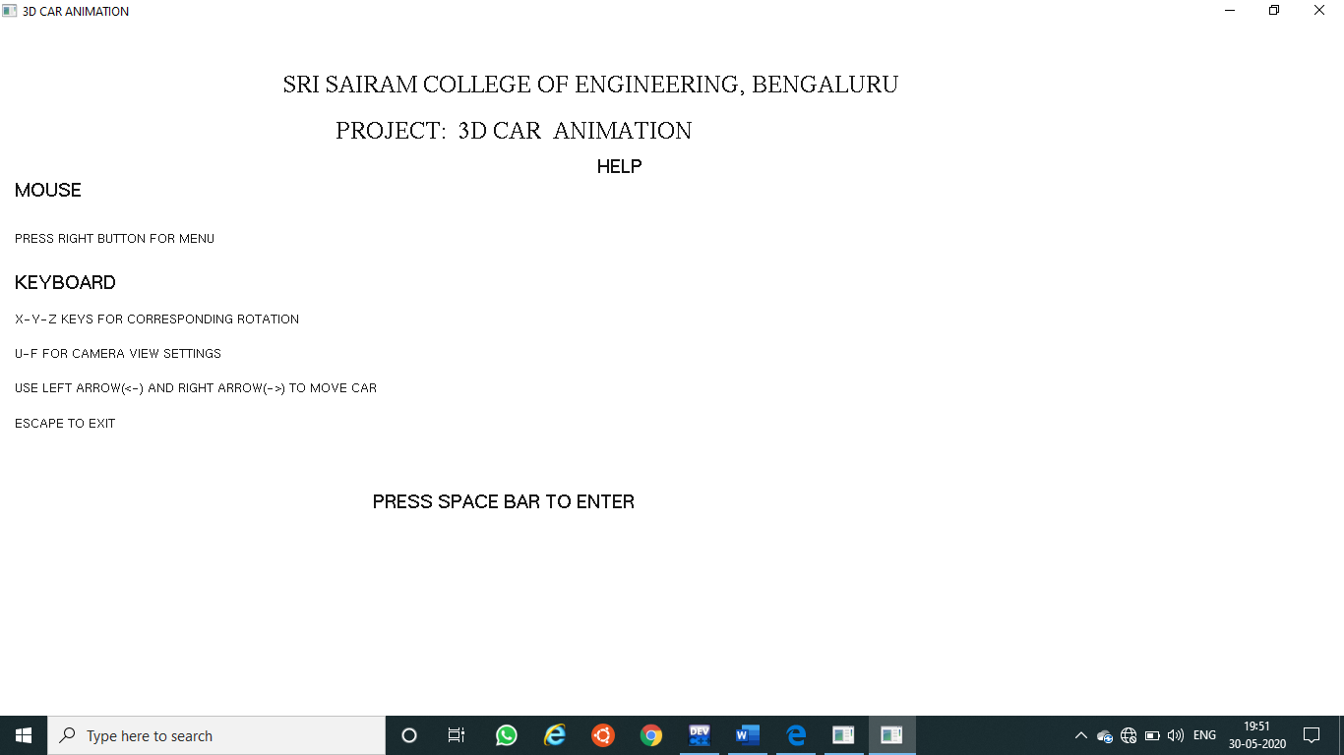

FIG.5.1 Starting menu of the project

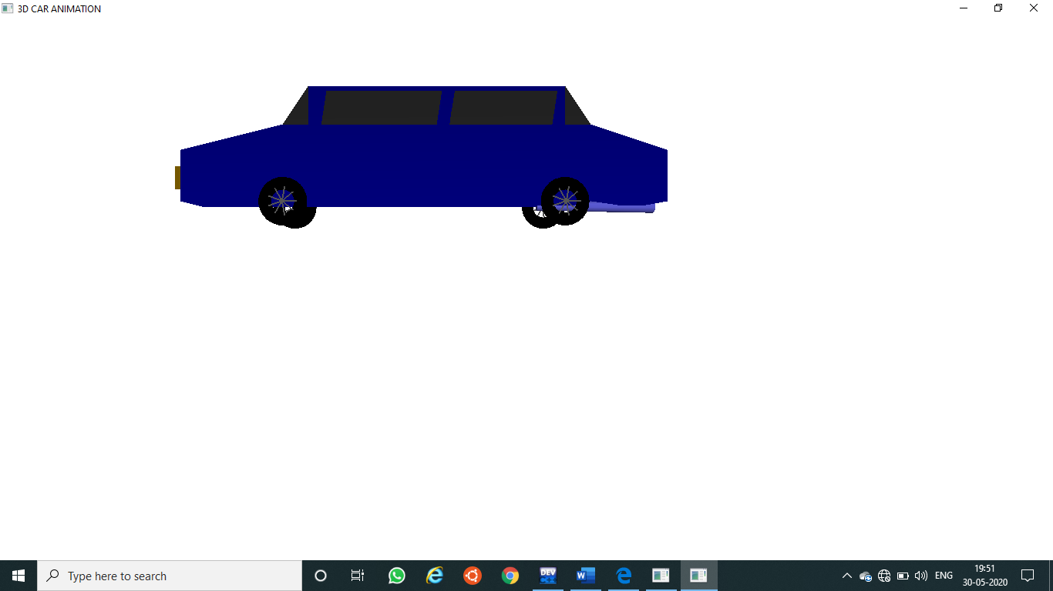

FIG 5.2 Inside the project

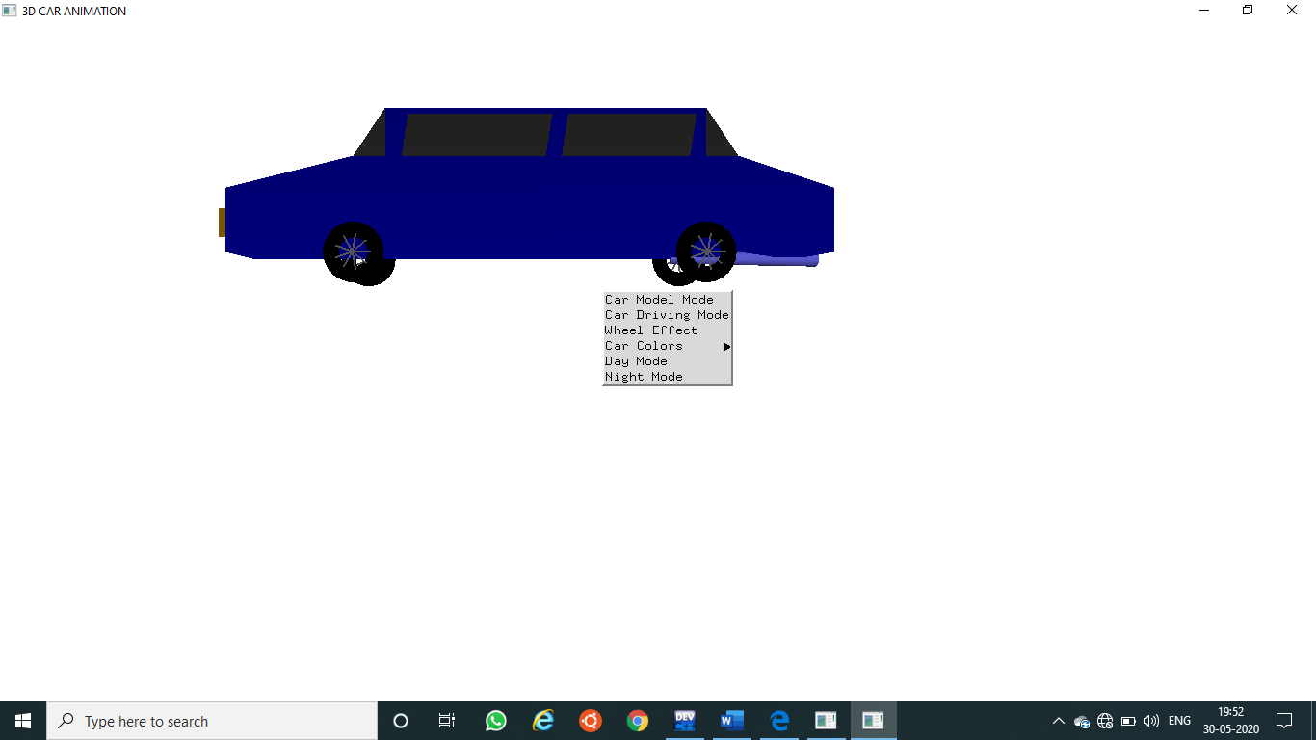

FIG 5.3 Different car options

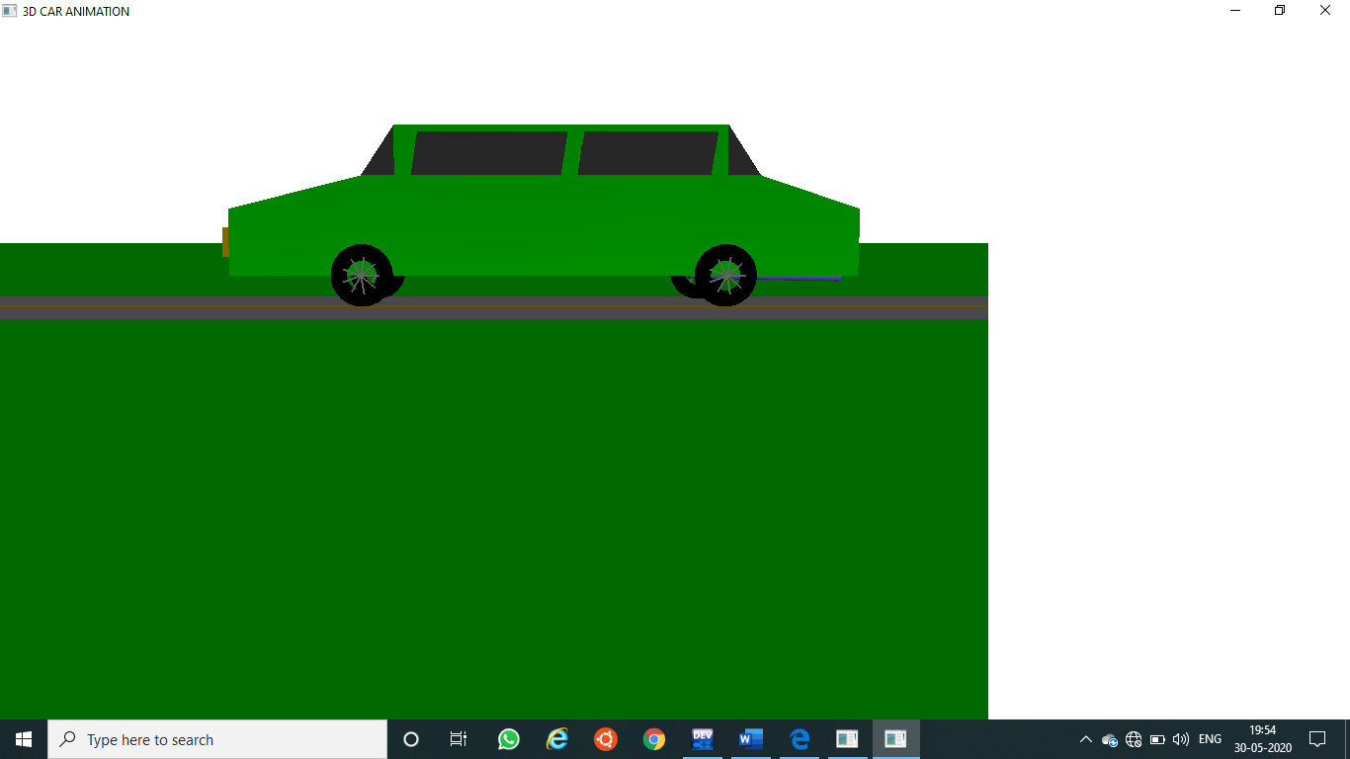

FIG 5.4 Car Driving Mode

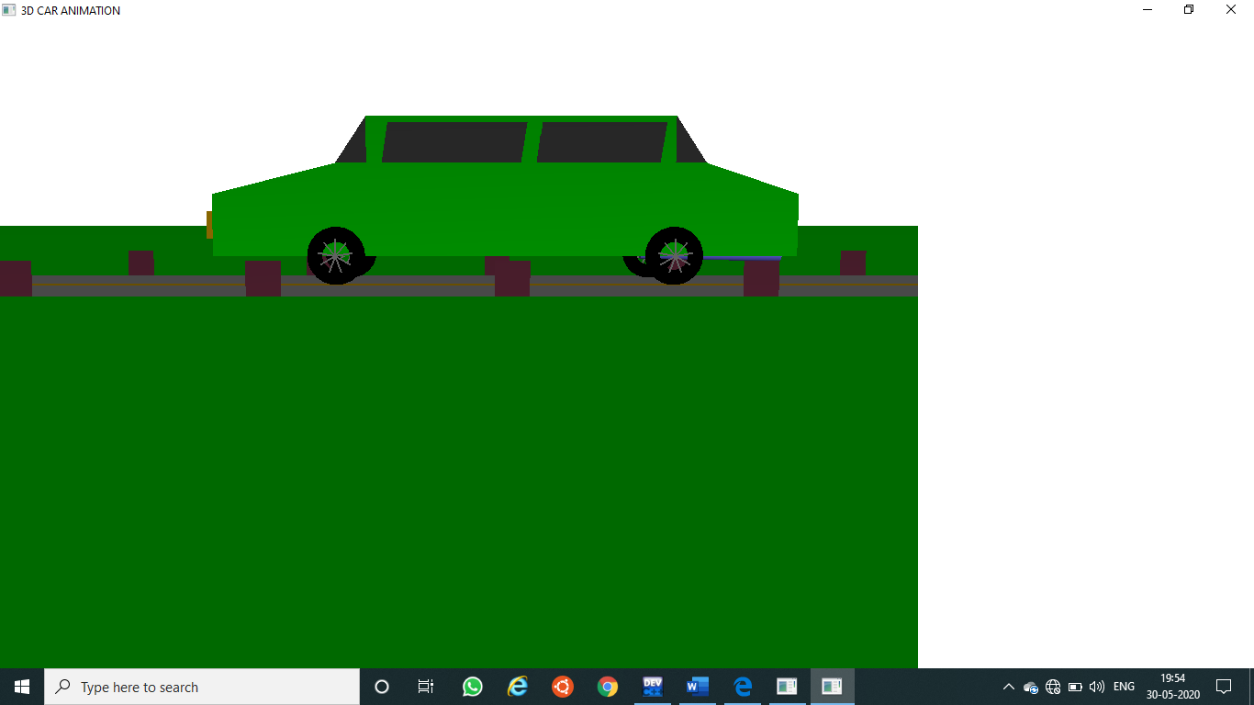

FIG.5.6.Wheel Effect

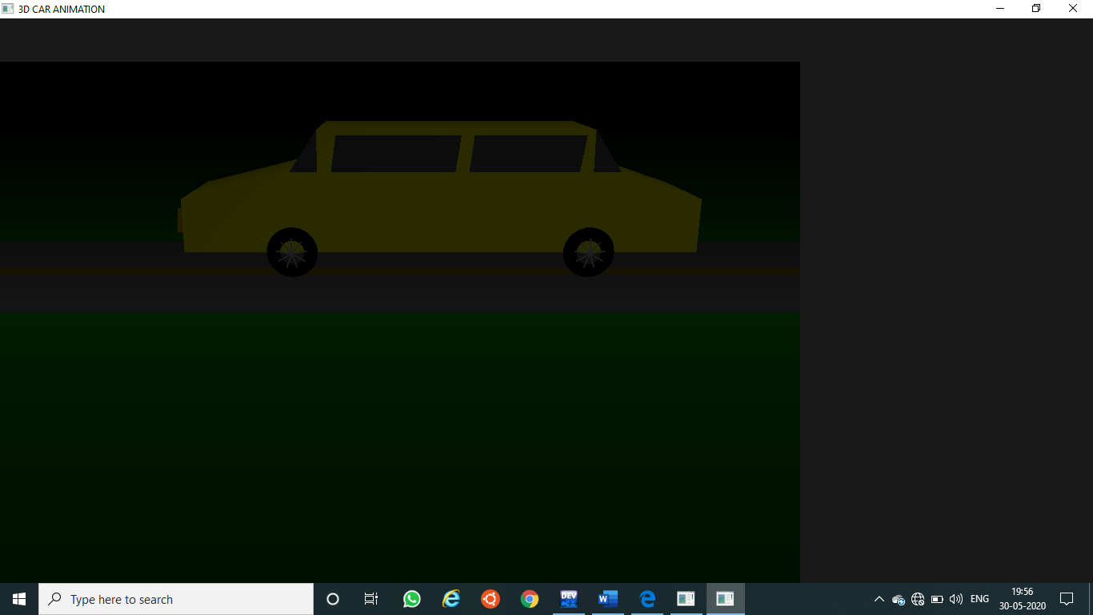

Fig 5.7 Night mode

**6.TESTING**

* 1. **LIFE CYCLE OF TESTING**



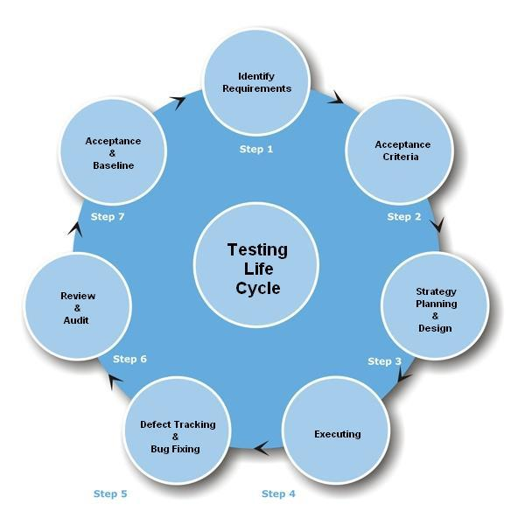

**FIG 6.1 TESTING LIFE CYCLE**

**6.2 TYPES OF TESTING**

**6.2.1 MANUAL TESTING**

Manual testing includes testing a software manually, i.e., without using any automated tool or any script. In this type, the tester takes over the role of an end-user and tests the software to identify any unexpected behavior or bug. There are different stages for manual testing such as unit testing, integration testing, system testing, and user acceptance testing.

**6.2.2 AUTOMATION TESTING**

Automation testing, which is also known as Test Automation, is when the tester writes scripts and uses another software to test the product. This process involves

automation of a manual process. Automation Testing is used to re-run the test scenarios that were performed manually, quickly, and repeatedly.

**6.2.3 BLACK-BOX TESTING**

The technique of testing without having any knowledge of the interior workings of the application is called black-box testing. The tester is oblivious to the system architecture and does not have access to the source code. Typically, while performing a black-box test, a tester will interact with the system's user interface by providing inputs and examining outputs without knowing how and where the inputs are worked upon.

**6.2.4 WHITE-BOX TESTING**

White-box testing is the detailed investigation of internal logic and structure of the code. White-box testing is also called **glass testing** or **open-box testing**. In order to perform **white-box** testing on an application, a tester needs to know the internal workings of the code. The tester needs to have a look inside the source code and find out which unit/chunk of the code is behaving inappropriately.

**6.2.5 GREY-BOX TESTING**

Grey-box testing is a technique to test the application with having a limited knowledge of the internal workings of an application. In software testing, the phrase the more you know, the better carries a lot of weight while testing an application.

**6.2.6 FUNCTIONAL TESTING**

This is a type of black-box testing that is based on the specifications of the software that is to be tested. The application is tested by providing input and then the results are examined that need to conform to the functionality it was intended for. Functional testing of a software is conducted on a complete, integrated system to evaluate the system's compliance with its specified requirements.

**6.2.7 UNIT TESTING**

This type of testing is performed by developers before the setup is handed over to the testing team to formally execute the test cases. Unit testing is performed by the respective developers on the individual units of source code assigned areas. The developers use test data that is different from the test data of the quality assurance team. The goal of unit testing is to isolate each part of the program and show that individual parts are correct in terms of requirements and functionality.

**6.2.8 INTEGRATION TESTING**

Integration testing is defined as the testing of combined parts of an application to determine if they function correctly. Integration testing can be done in two ways: Bottom-up integration testing and Top-down integration testing.

**6.2.9 SYSTEM TESTING**

System testing tests the system as a whole. Once all the components are integrated, the application as a whole is tested rigorously to see that it meets the specified Quality Standards. This type of testing is performed by a specialized testing team.

**6.3.0 REGRESSION TESTING**

Whenever a change in a software application is made, it is quite possible that other areas within the application have been affected by this change. Regression testing is performed to verify that a fixed bug hasn't resulted in another functionality or business rule violation. The intent of regression testing is to ensure that a change, such as a bug fix should not result in another fault being uncovered in the application.

**6.3.1 ACCEPTANCE TESTING**

This is arguably the most important type of testing, as it is conducted by the Quality Assurance Team who will gauge whether the application meets the intended specifications and satisfies the client’s requirement. The QA team will have a set of pre-written scenarios and test cases that will be used to test the application. By performing acceptance tests on an application, the testing team will deduce how the application will perform in production. There are also legal and contractual requirements for acceptance of the system.

**6.3.2 ALPHA TESTING**

This test is the first stage of testing and will be performed amongst the teams (developer and QA teams). Unit testing, integration testing and system testing when combined together is known as alpha testing. During this phase, the following aspects will be tested in the application:

* Spelling Mistakes
* Broken Links
* Cloudy Directions
* The Application will be tested on machines with the lowest specification to test loading times and any latency problems.
  1. **BETA TESTING**

This test is performed after alpha testing has been successfully performed. In beta testing, a sample of the intended audience tests the application. Beta testing is also known as **pre-release testing**. Beta test versions of software are ideally distributed to a wide audience on the Web, partly to give the program a "real-world" test and partly to provide a preview of the next release. In this phase, the audience will be testing the following:

* Users will install, run the application and send their feedback to the project team
* Typographical errors, confusing application flow, and even crashes.
* Getting the feedback, the project team can fix the problems before releasing the software to the actual users.
  + 1. **NON-FUNCTIONAL TESTING**

This section is based upon testing an application from its non-functional attributes. Non-functional testing involves testing a software from the requirements which are nonfunctional in nature but important such as performance, security, user interface, etc. Some of the important and commonly used non-functional

* Load Testing
* Performance Testing
* Stress Testing

**7. CONCLUSION**

It has been an interesting journey through the development of this project. At the beginning we used our limited knowledge to implement only the basic features. However, through the months of development, new issues and bugs led to new ideas which led to newer methods of implementation which, in turn, led to us learning even more features of the OpenGL and apply more creative and efficient ways to perform the older functions. New methods helped us in adding flexibility to the various parts of the program, making the further addition of newer features easier and less time consuming which, again, led to the possibility of adding even more features. This sequential chain reaction of progress and ideas has enabled to learn so much through the months of working on this project and we have done our best to add as many features as we could and provide a user interface that is easy and intuitive to use.

Before concluding, it is worth mentioning that this project would never have been possible without the tremendous amount of encouragement by the staff and guides of our department.

We are content with the outcome of this project and are hopeful that it meets the requirements expected and we wish that it may inspire others to be creative and critical in the field of computer graphics and have a newfound appreciation for the Open Graphics Library.

Although it isn’t noticeable on a relatively newer and powerful processor, the method of applying the transforms pixel by pixel is a very taxing process, especially for larger images of 1080p or higher. A possible feature to implement could be to perform all the transforms using multithreading to split the workload onto multiple threads, reducing the minimum computational time required between time steps.

• Since Contrast modifies the RGB values instead of HSL, the contrast should be the last thing that should be changed after changing any brightness or saturation.

• Addition of complete pixel blur in both directions, and several other transforms is also notable.

• Allowing the user to select his own color model from RGB, HSL, HSV etc. to allow more fine tuning of the Image.

• More efficient memory management techniques to prevent heavy usage of memory

**8. BIBILIOGRAPHY**

**REFERENCE BOOKS:**

**[1] Donald Hearn & Pauline Baker: Computer Graphics with OpenGL Version,3rd/4th Edition, Pearson Education,2011**

**[2] Edward Angel: Interactive Computer Graphics- A Top Down approach with OpenGL, 5th edition. Pearson Education, 2008**

**Web Sites:**

*http://msdn.microsoft.com*

[*http://codeproject.com*](http://codeproject.com)

*http://stackoverflow.com*